 | 12.1.15 Editors - Geometry Nodes Editor - Header - Add Menu - Geometry - Material
Table of content
Detailed table of content 1
Add menu - Geometry - Material 3
Replace Material. 3
Material Index 3
Material Selection 4
Set Material 4
Set Material Index 4

Detailed table of content
Detailed table of content
Detailed table of content 1
Add menu - Geometry - Material 2
Replace Material. 2
Inputs 2
Geometry 2
Old 2
New 2
Outputs 2
Geometry 2
Material Index 2
Outputs 2
Material Index 2
Material Selection 3
Inputs 3
Geometry 3
Outputs 3
Material Index 3
Set Material 3
Inputs 3
Geometry 3
Selection 3
Material 3
Outputs 3
Geometry 3
Set Material Index 3
Inputs 3
Geometry 3
Selection 4
Material Index 4
Outputs 4
Geometry 4

Add menu - Geometry - Material
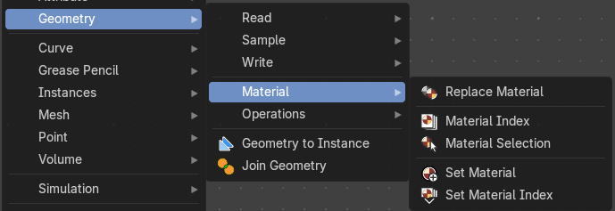
Here you find nodes to modify the material.

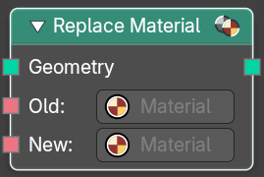
Replace Material.
Sets the name of the target geometry.

Inputs

Geometry
Geometry input.

Old
The material that you want to replace.

New
The new material that replaces the old material.

Outputs

Geometry
Geometry output.

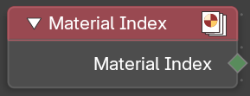
Material Index
Retreive the material index.

Outputs

Material Index
The material index.

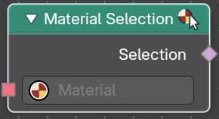
Material Selection
Select a mesh part by material.

Inputs

Geometry
Geometry input.

Outputs

Material Index
The material index.

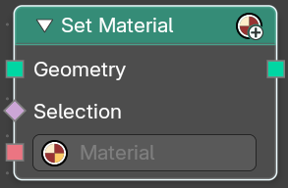
Set Material
Assign a material to a selection.

Inputs

Geometry
Geometry input.

Selection
The selection of the geometry.

Material
The material to assign.

Outputs

Geometry
The geometry with the new material assigned.

Set Material Index
Set the material index of a selection.

Inputs

Geometry
Geometry input.

Selection
The selection of the geometry.

Material Index
The material index to assign to the selection.

Outputs

Geometry
The geometry with the new material index assigned.

